**DATA SCIENCE EVALUATION 2**

1. State the Null and Alternative Hypothesis.

75% of the flowers will be purple

75% of the flowers will not be a purple

1. What statistic do you recommend to apply for this case.

z-test can be applied since the size of the sample is 929.

1. State the observed statistic.

Observed test statisticis there are 721 purple flowers out of 929.

1. Simulate the test statistic under the Null that will help make the decision(5). The number of simulations should be equal to

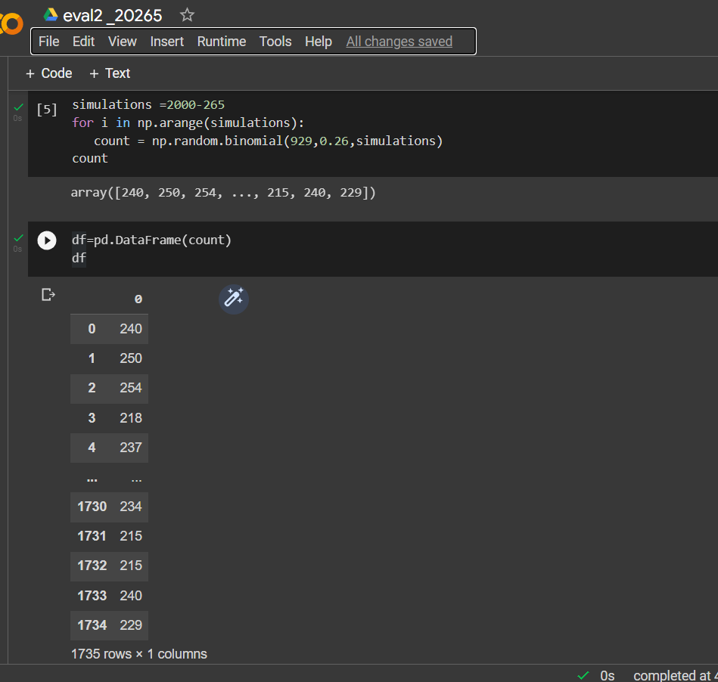

1. Draw a histogram to depict what the model of random selection predicts about the statistic.(4). Depict the observed statistic as a red dot on the histogram(1).

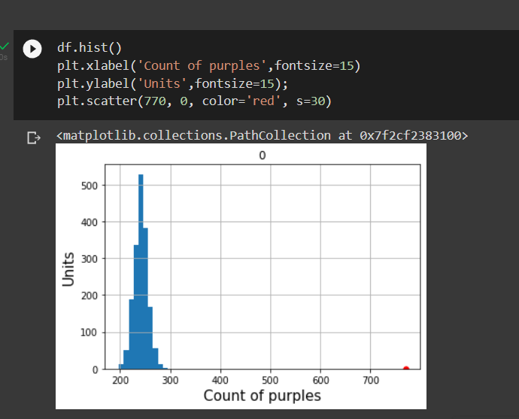

6. . What is the outcome of your analysis?

Since the value721 in the histogram near to the centre there it is highly significance that the sample may occur.

So we could reject the null hypothesis,